Homemade Healthy Dog Food
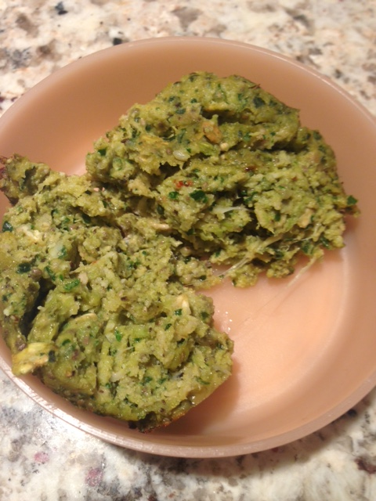

Ingredients:

- 1 (15 oz.) can yams or pumpkin puree
- 1 apple, chopped into large chunks
- 5 fresh kale leaves, ribs included
- 2 tablespoons coconut oil
- 2 tablespoons Dog Sprinkles
- 2 tablespoons chia seeds
- 2 tablespoons nori flakes
- 3 tablespoons Parmesan cheese, grated
- Pinch Himalayan crystal salt
- 16 oz. package ground turkey
- ½ cup rolled oats
- ½ cup almond flour

Preheat oven to 375°F. In a food processor, blend yams, apple, and kale together until well blended. Next, add in coconut oil, Dog Sprinkles, chia seeds, and nori flakes.

In a large mixing bowl, add the ground turkey, puree, rolled oats, almond flour, Parmesan cheese, and pinch of salt. Mix well.

In a 12-cup muffin tin lightly greased, or lined with muffin liners, scoop mixture into each cup (I find using an ice cream scooper the easiest way to do this). Bake for 15-20 minutes. Let cool and store in refrigerator. Makes about 16 meals.

